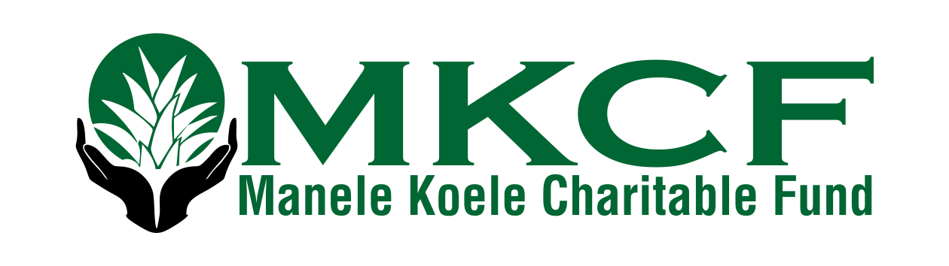

Application Process:
Please complete this WORD document and send it to info@manelekoele.org.

Funding Request Form: Date:

- Name of Requester:
Organization :
Requesters Contact information:
  - Phone number:
  - Email:

- Is this organization a 501C3?
IF NO, Fiduciary and/or 501C3 sponsor?
Fiduciary Address:
Name to appear on check?
EIN#:

- Current Project:
  - Name of Project:
  - Rationale for Project:

- Total amount of Funding Request:
Date funds will be needed:

- Itemized breakdown of budget request: (can be inserted here or sent as separate attachment)

- Identify who would benefit from the funding request: (age groups, number, and demographics of targeted population)

- What specifics goals are you trying to achieve?
How will you evaluate success?

- Other sources of funding the group has received or is planning on applying for:

Supply a community reference and their contact information:

If you would like to include additional materials such as pictures, websites, etc. to support your application, please attach them as separate documents or include links to them. These additional materials are welcomed, but not required.

